Installing & Configuring the Metasploit Framework:
Can be installed on window and Linux.

In kali the msfconsole is preinstalled/pre-packaged:
We only need to update it.

A standalone package is software bundled with everything it needs (libraries, resources) so it can run independently without installing additional dependencies.

Database: msfdb
Used by msf to store data such as scan results, host data etc.

Postgresql database as primary database server. It must be running and configured correctly to store data in msfconsole.

Importation from nmap and nessus.

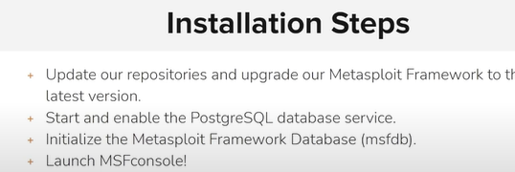

DEMO:
Sudo apt-get update
Sudo apt-get install Metasploit-framework
# is it is already installed; it updates and then upgrades the repo to the latest version.

Sudo systemctl enable postgresql
# it start up when the system is start. (debian)

Sudo systemctl start postgresql
# start immediately

Sudo systemctl status postgresql
# show status

Sudo msfdb
# to manage the database server (postgresql)

Sudo msfdb init
# to initialize it.

# if face any issue with database then reinit it.
Sudo msfdb reinit
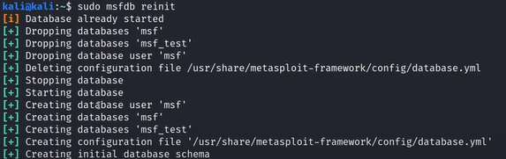

Sudo msfdb status
# to check status

Msfconsole -q
Db_status
# to check that database is connected.

NOTE:
• Debian-based (Ubuntu, Kali, Linux Mint, etc.)
• Red Hat-based (RHEL, CentOS, Fedora, Rocky, AlmaLinux)
• Arch-based (Arch Linux, Manjaro, EndeavourOS)
• SUSE-based (openSUSE, SUSE Linux Enterprise)
• Independent (Gentoo, Slackware, Alpine, Void, NixOS).

sudo systemctl enable postgresql means PostgreSQL will auto-start on the next boot, but it does not start the service immediately.
PostgreSQL will start automatically on every future boot until you disable it (sudo systemctl disable postgresql).

sudo service postgresql start / sudo systemctl start postgresql(server) → only starts the PostgreSQL database service.
sudo msfdb init (utility)→ does more: it initializes the Metasploit database (creates the DB, user, schema, starts the service, etc.) and starts the PostgreSQL service if it’s not running.

